NAME:____________________________________

FINAL EXAM

This exam is open:

books

notes

and closed:

neighbors

calculators

The upper bound on exam time is 3 hours.

Please put all your work on the exam paper.

(Partial credit will only be given if your work is shown.)

Good luck!



PLEASE DO NOT FORGET TO FILL OUT AN ON-LINE COURSE EVALUATION!

1. (15 points) Function Order of Growth

(6 points) List the 4 functions below in nondecreasing asymptotic order of growth:

1) 2) 3) 4)
smallest largest

Given:
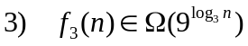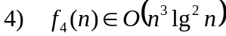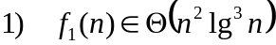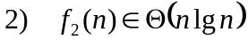

Circle TRUE or FALSE for each statement below

b) (1 point) 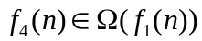

TRUE FALSE

c) (1 point) 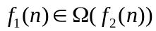

TRUE FALSE

d) (1 point) 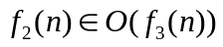

TRUE FALSE

e) (1 point) 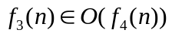

TRUE FALSE

f) (5 points) Circle TRUE or FALSE for the statement below:

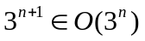

TRUE FALSE

this page intentionally left blank for work
- (20 points) Pseudocode Analysis.

In this problem a linked list L is searched from both ends for a key k. If k is in the list, a pointer to the node containing k should be returned. Otherwise, NIL should be returned. The list L is doubly-linked and has both head and tail pointers.

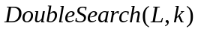
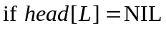
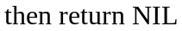
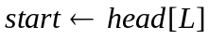
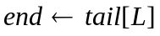
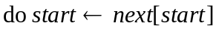
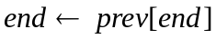
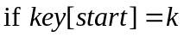
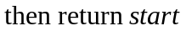
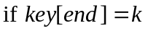
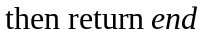
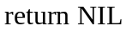

- (8 points) Is the pseudocode correct? If not, fix it. Justify your answer.

this page intentionally left blank for work

The remainder of this problem refers to the pseudocode fixed, if necessary, by you.

- (2 points) Show a best-case input for DoubleSearch. How does this compare with a best-case input for LIST-SEARCH on p. 205 of our textbook?

- (2 points) Show a worst-case input for DoubleSearch. How does this compare with a worst-case input for LIST-SEARCH on p. 205 of our textbook?
- (2 points) Analyze the asymptotic best-case running time of DoubleSearch as a function of n = length[L]. Provide a tight upper bound and a tight lower bound. Does this change if L is sorted by nondecreasing key value? Why or why not?

- (2 points) Analyze the asymptotic worst-case running time of DoubleSearch as a function of n = length[L]. Provide a tight upper bound and a tight lower bound. Does this change if L is sorted by nondecreasing key value? Why or why not?

- (2 points) Analyze the best-case running time of DoubleSearch by counting exactly how many total times a key reference is performed (example: key[x]). Compare this with the total number of times a key reference is performed in the best case for the LIST-SEARCH pseudocode on p. 205 of the textbook.

- (2 points) Analyze the worst-case running time of DoubleSearch by counting exactly how many total times a key reference is performed (example: key[x]). Compare this with the total number of times a key reference is performed in the worst case for the LIST-SEARCH pseudocode on p. 205 of the textbook.

- (10 points) Binary Search Trees

  - (5 points) Is the tree below a legal red/black tree? Why or why not?

75
70
60
20
40
90
80

In the figure, shaded nodes are black and unshaded nodes are red.

  - (5 points) Find a sequence of left and/or right rotations to transform Binary Search Tree A into Binary Search Tree B.

Tree B
Tree A

50
25
5
30
10
15
75
70
80
60
73
50
25
75
5
10
15
30
60
70
73
80

4. (15 points) Recurrence

Find the tightest upper bound that you can on the closed-form solution for the following recurrence:

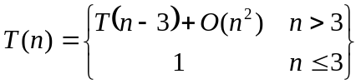

this page intentionally left blank for work
5. (5 points) Hash Tables.

For integer values of k, circle all the different values that can be obtained using the hash function:

h(k) = (k² + 4) mod 6

(a) 0 (b) 1 (c) 2 (d) 3

(e) 4 (f) 5 (g) 6 (h) 7

(i) 8 (j) 9 (k) 10 (l) 11

this page intentionally left blank for work

6. (5 points) Graphs

For the directed graph below on the left, give an adjacency list representation of the graph that produces the DFS tree on the right.

(In the DFS tree, thick, solid arrows are tree edges and dashed arrows are either forward or back edges.)

D
E
C
A
B
D
E
A
B
C

this page intentionally left blank for work
7. (30 points) Designing an Algorithm

In this problem you will design an efficient algorithm that accepts, as input:
- a set A of n integers
- a set B of m integers

Your algorithm should return:

Example: 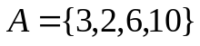, 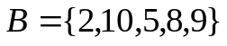, 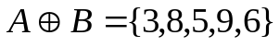

Your algorithm should be efficient in its usage of running time and storage. You may decide how A and B and 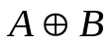are represented.

See the next several pages for parts (a), (b), and (c) that ask for pseudocode, correctness and analysis.

Note/Hint: If you use any algorithm from the textbook, without modifications, then you do not need to write down all its steps – just reference the page number and name of the procedure. In this case, you can also reference its correctness proof and analysis. However, if you modify an algorithm from the textbook, you need to write down your modifications to the pseudocode, correctness justification and analysis.

- (10 points) Pseudocode. Describe your algorithm using the pseudocode conventions in our textbook.

- (10 points) Correctness.

- (10 points) Running Time Analysis. Give a worst-case asymptotic upper bound and a worst-case asymptotic lower bound on the running time of your algorithm as a function of n and m. Explain your answer.

